International Lighthouse Weekend 2022
August 21-22nd Cape Nelson AU0055 VK3ILH

Well after almost 2 years of COVID lockdown and travel restrictions in Victoria, finally we could plan to go to the coast. Find a real lighthouse and be a part of this world-wide amateur radio event.
Previous years apart from the COVID period, did operate from Port Albert Maritime Museum. Which was good, but limited space for antennas, around the external exhibits. Plus, the coffee shop across the road had recently closed, excellent coffee and food there.
There are a number of lighthouse opportunities around the Victorian coast, the closer ones to Melbourne are registered quite early. I think about 9 lighthouses registered this year.
So looking at the options, its always good to find accommodation on-site from which to operate from, so your operating hours can be endless. Plus somewhere warm, good heating, given it is winter in the Southern Hemisphere, mains power. You also look at other on-site facilities, like a Café.
Cape Nelson, Portland seemed ideal, given I last activated the site in 2009. It was time to return. Cape Nelson is 360 km west of Melbourne, just over 4 hours drive. Named after Lieutenant James Grant ship the Lady Nelson, was built in 1884. With a Chance Brothers 3.6m lantern. The lighthouse was constructed from local stone and is about 32m high. Its positioned on the cliff top, with a stone wind wall leading back to the old stables, and further back keepers cottages.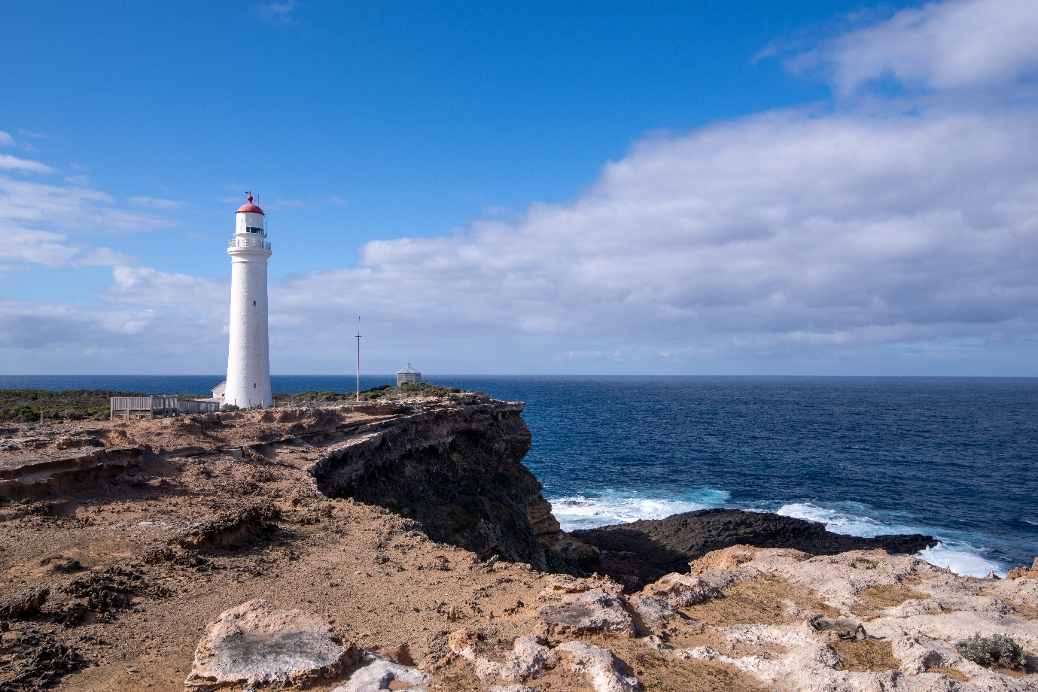
The stables now Isabella’s café named after a shipwreck, and the keeper’s cottages now fully renovated with modern necessities. Large fenced grounds around each cottage offered generous spaces for antennas. But no trees, or standing poles to support wire antennas.
We drove down there on the Friday morning, Margaret XYL and myself. Established the QTH, set up the Cushcraft R5 vertical, so at least we had 10-20 metres we could operate on. That afternoon using 100 watts put out a few calls and worked France, Italy, USA, all with very good signal reports.
That night the weather was not going to disappoint, it blew a gale, heavy rain was even going sideways. The R5 was in its element bending gracefully but not yielding. But what should you expected located on Victoria’s south west coast, and a southerly cold front comes through.
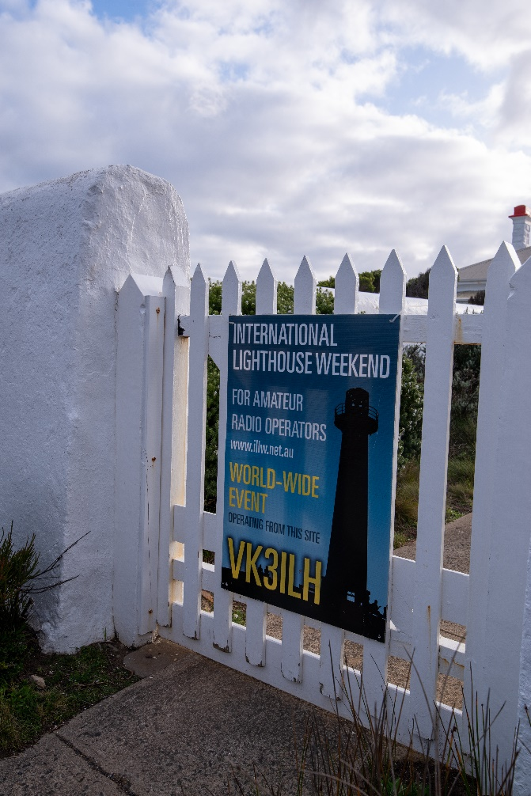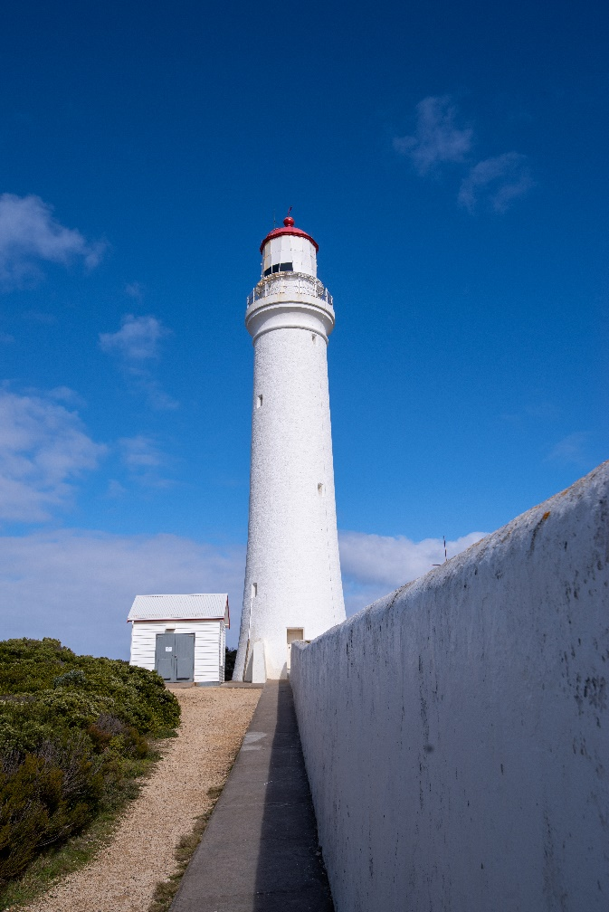
The wind was like a constant freight train hurtling past the keeper’s cottage. One could be very grateful that the cottage was very well built from local stone and not straw.
The next morning, Saturday Darrin Pearce arrived to offer much needed help and support. Plus, a Squid pole, with various dipole wires, both centre feed 40m and end feed for 80m. The rig ICOM 775, one could describe as a beast, built-in power supply and tuner. Had no issues in tuning both wire and vertical antennas. It is a heavy rig to use in portable operations. The other delight about working from these locations, there is no RF noise, none. So, if there is even a very weak signal you can still work them. Quite different to some Melbourne locations. Photo below vertical antenna, squid pole, our cottage and Cape Nelson lighthouse.
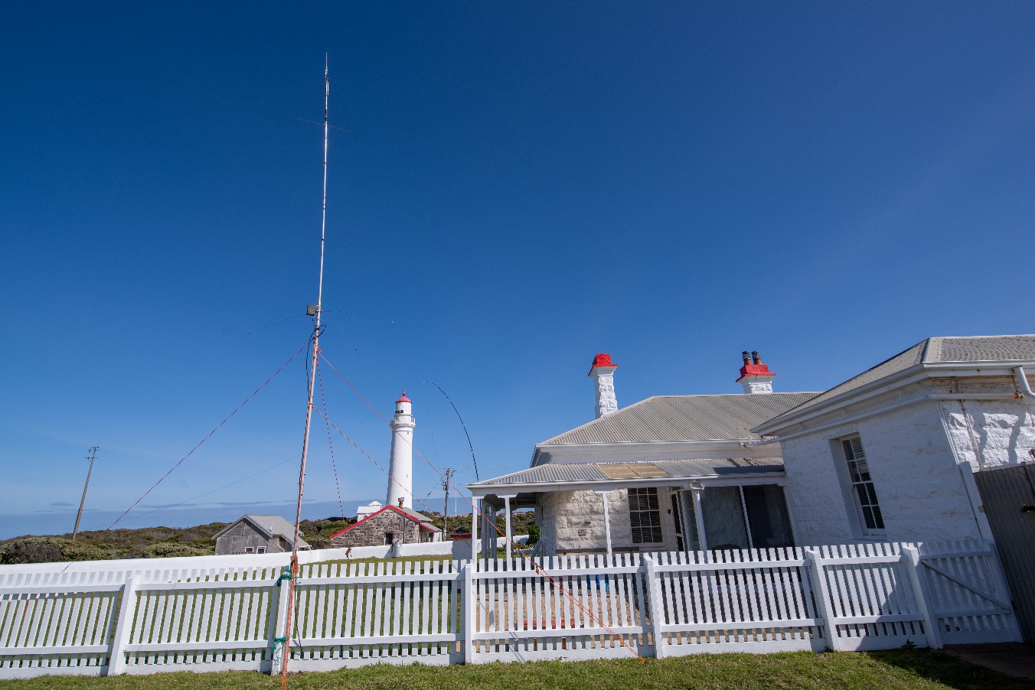
Over the 2 days we worked around 80 contacts, some of the countries France, Italy, USA, Hungary, Israel, Sicily, Germany, Spain, Belgium, New Zealand. Plus many Australian stations and lighthouses. Also some club members VK3RU and VK3PZ.
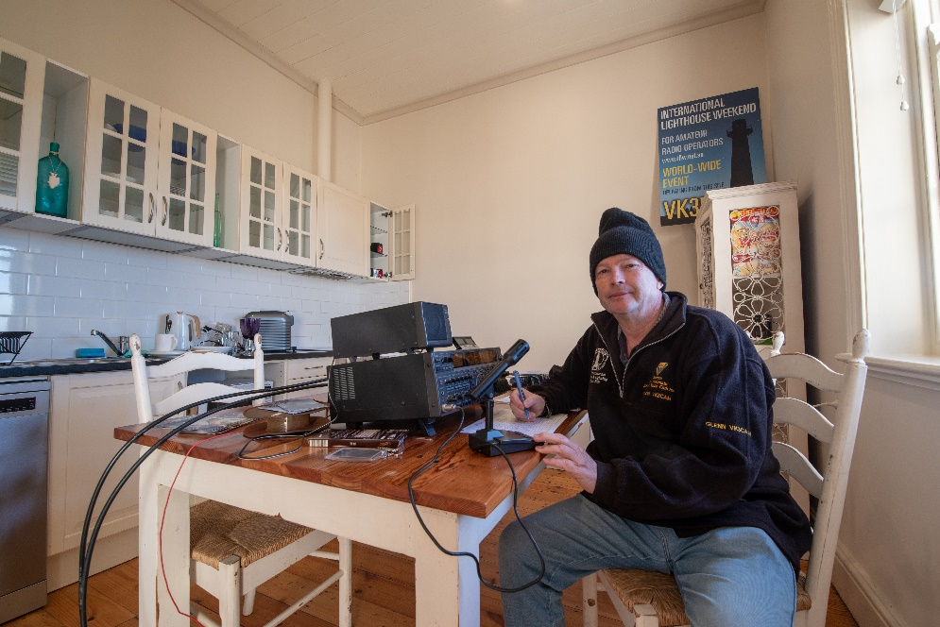
So great weekend, good coffee at Isabella’s café and in easy walking distances. Also good for take aways if needed.
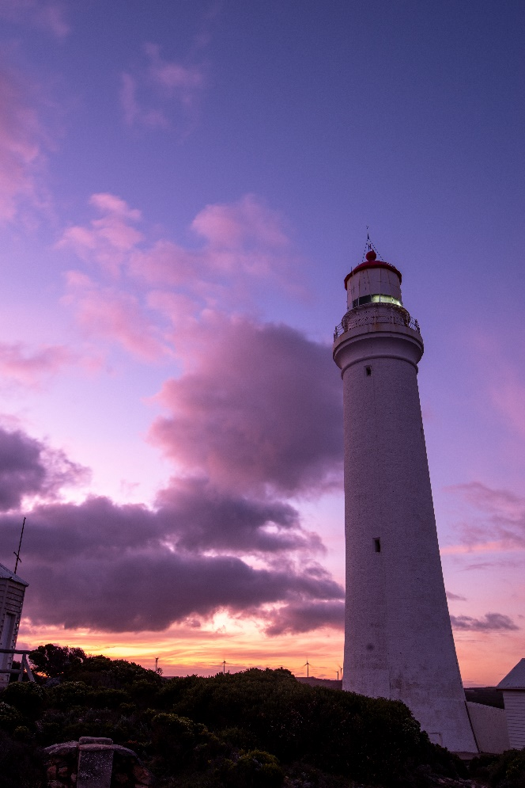
There are also some very good walks around Portland coastal Park. This time of the year also the chance of whale spotting along the coast. The other great asset is the changeable colours as the day progresses towards sunset. Quite incredible.
So, if you haven’t participated in the International Lighthouse Weekend, it’s held every year around mid-August. Its not a competition. Information and registrations can be found on www.illw.net
This year about 370 world-wide registrations.
So go to it… 73’s 