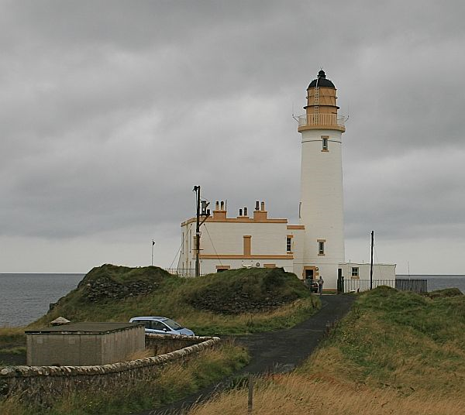
Turnberry Lighthouse ILLW UK0000
A few years ago the International Association of Lighthouse Keepers decided to have an annual open day for lighthouses all around the world to encourage visitors to visit at their lighthouses. They decided that no better day could be decided upon other than the Sunday of the ILLW. This move has been highly successful as the media have become involved in quite a few of the countries involved in the event.
This year’s event takes place on the 3rd full weekend in August so if you haven’t done so already, find a lighthouse nearby and get a group together or do it solo and fire up a lighthouse station. In most cases if you don’t intend operating from within the lighthouse itself or one of its cottages, you really don’t need to get any approval. Most first time entrants are so enthused with the event that they return year after year. A report from the Burlington ARC, Canada summed their first participation in these few words:
“The greatest delight of the day was the active participation of the visiting children who showed a remarkable interest in the whole idea of amateur radio, especially the use of Morse Code.
It was an honour and a delight to participate in this adventure and we look forward with increased enthusiasm to next year's participation.”
Sadly, Mike Dalrymple passed away in December 2005. He was the Treasurer of the Ayr Amateur Radio Group. The event is now dedicated to Mike’s memory as is this official ILLW web site where you will find the event guidelines, an on line entry form and lists of participating lighthouse since 1999. In recognition of the link between Mike and Turnberry lighthouse, it now carries the unique ILLW identification number UK0000. Mike's friend, John Forsyth GM4OOU, is still in Scotland and is quite impressed and amazed the way their "baby" has grown over the years.

https://illw.net



Kevin vk2ce

Copyright © 2021

International Lighthouse Lightship Weekend - ILLW

00.01UTC 21 August 2021 to 2400UTC 22 August 2021 (48 hours)
For some reason or other August seems to have become the international weekend for lighthouses. Countries all over the world have become involved in one for or another of lighthouse activity. Some years ago the United States Congress declared August 7th as their National Lighthouse Day and during that first week in August amateur radio operators in America set up portable stations at lighthouses and endeavour to make contact with each other. Unlike the ILLW there are prizes and certificates awarded for this event.
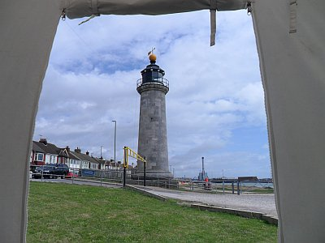
Shoreham Lighthouse, Southern England. Photo: M0MNG

The Association of Lighthouse Keepers, ALK, conducts International Lighthouse Heritage Weekend on the 3rd full weekend in August. Their objective is to encourage Lighthouse managers, keepers and owners to open their lighthouse or lightstation and related visitors centres to the public with a view to raising the profile of lighthouses, lightvessels and other navigational aids, and preserving our maritime heritage.
However, the major event which takes place in August is the International Lighthouse Lightship Weekend, ILLW, which came into being in 1998 as the Scottish Northern Lights Award run by the Ayr Amateur Radio Group. The history of this event can be found elsewhere on this site. The ILLW takes place on the 3rd full weekend in August each year and attracts over 500 lighthouse entries located in over 40 countries. It is one of the most popular international amateur radio events in existence probably because there are very few rules and it is not the usual contest type event. It is also free and there are no prizes for contacting large numbers of other stations. There is little doubt that the month of August has become "Lighthouse Month" due largely to the popularity and growth of the ILLW.

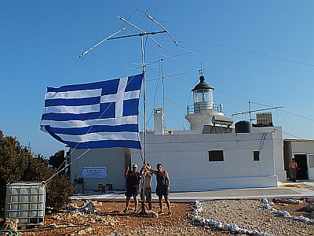

History of the Lighthouse Weekend

It all started in 1993 during a wet wintry evening when two members of the AYR Amateur Radio Group in Scotland, John GM4OOU and the late Mike GM4SUC, after a club meeting were talking about creating an event in the summer when club members could get out on a sunny weekend and play radio. Various themes were considered; ports, airports, historic Scotland sites, the Firths of Scotland, castles etc. but it was finally decided that lighthouses of Scotland would be ideal.
Following research it was discovered that the lighthouses of Scotland were controlled by the Northern Lighthouse Board in Edinburgh who were not only responsible for the lighthouses of Scotland, but also around the Isle of Man. Approval was sought and obtained from the Northern Lighthouse Board to establish amateur radio stations adjacent to their property. In February 1993 an invitation was sent to all Scottish clubs and the Isle of Man club to join in the fun of a weekend, to be called the Northern Lighthouse Activity Weekend, by establishing an amateur radio station at a lighthouse during the third weekend in August. This first year's event saw 11 stations established at lighthouses, operating primarily on the HF bands, with each station making approximately 750 QSOs over the weekend.
The following year the Scottish clubs were involved in a weekend activity with the theme of Scottish Firths (river estuaries), so two years elapsed before the next Northern Lighthouse Activity Weekend. During this period Anne-Grete OZ3AE enquired through a letter to Practical Wireless if there was any lighthouse activity on amateur radio. Following discussions with her it was decided that Danish stations could join in the fun of the weekend. Quickly Germany, South Africa and France asked to join, so the name of weekend was changed to The International Lighthouse/Lightship Weekend . It was at this time that John, GM4OOU, due to pressure of work, had to cease his connections with the event. The weekend became an annual event taking place over the third full weekend in August and has slowly grown in popularity and in 1999 there were 204 lighthouse/lightship stations in 36 countries until now when some 450 stations in over 50 countries take part. Full statistics and guidelines for participation can be found elsewhere on this web site.
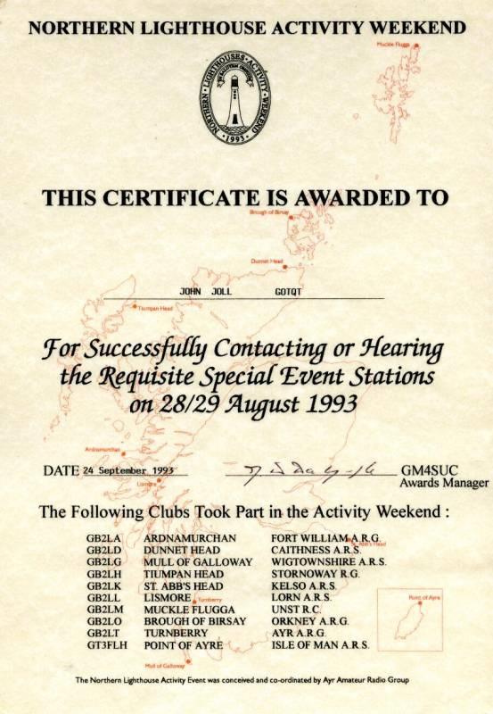
August 1993 Certificate
The main reason the event has become so popular is because it is NOT a contest. It is a relaxed fun weekend without the pressure of a contest. The guidelines are simple and the onus is on the operators to act within the spirit of the weekend which is simply to expose amateur radio and the plight of lighthouses to the public. This is why it is important for the ham station to be as close to the lighthouse/lightship as possible and with the controlling body’s approval.

