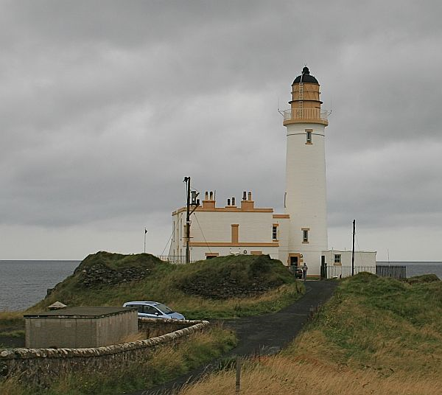
A few years ago the International Association of Lighthouse Keepers decided to have an annual open day for lighthouses all around the world to encourage visitors to visit at their lighthouses. They decided that no better day could be decided upon other than the Sunday of the ILLW. This move has been highly successful as the media have become involved in quite a few of the countries involved in the event.

The event takes place on the 3rd full weekend in August so if you haven’t done so already, find a lighthouse nearby and get a group together or do it solo and fire up a lighthouse station. In most cases if you don’t intend operating from within the lighthouse itself or one of its cottages, you really don’t need to get any approval.
Most first time entrants are so enthused with the event that they return year after year. A report from the Burlington ARC, Canada summed their first participation in these few words: education.
“The greatest delight of the day was the active participation of the visiting children who showed a remarkable interest in the whole idea of amateur radio, especially the use of Morse Code.
It was an honor and a delight to participate in this adventure and we look forward with increased enthusiasm to next year's participation.”
Mike Dalrymple passed away in December 2005. He was the Treasurer of the Ayr Amateur Radio Group and one of their members has taken on Mike’s roll as the PR man and main co-ordinator. The event is now dedicated to Mike’s memory as is the official web site http://illw.net where you will find event guidelines, an on line entry forms and list of participating lighthouse since 1998.
Purpose:
The basic objective of the event is to promote public awareness of lighthouses and lightships and their need for preservation and restoration, to promote amateur radio and to foster International goodwill.

International Lighthouse/
Lightship Weekend

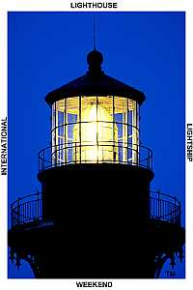

The oldest and original International Amateur Radio Lighthouse Weekend event.

The Next Event
15-16 August 2015

History of the Event:
It all started in 1994 during a wet wintry evening when two members of the AYR Amateur Radio Group in Scotland, John GM4OOU and the late Mike GM4SUC, after a club meeting were talking about creating an event in the summer when club members could get out on a sunny weekend and play radio. Various themes were considered; ports, airports, historic Scotland sites, the Firths of Scotland, castles etc. but it was finally decided that lighthouses of Scotland would be ideal.
Following research it was discovered that the lighthouses of Scotland were controlled by the Northern Lighthouse Board in Edinburgh who were not only responsible for the lighthouses of Scotland, but also around the Isle of Man. Approval was sought and obtained from the Northern Lighthouse Board to establish amateur radio stations adjacent to their property. In February 1993 an invitation was sent to all Scottish clubs and the Isle of Man club to join in the fun of a weekend, to be called the Northern Lighthouse Activity Weekend, by establishing an amateur radio station at a lighthouse during the third weekend in August. This first year's event saw 11 stations established at lighthouses, operating primarily on the HF bands, with each station making approximately 750 QSOs over the weekend.
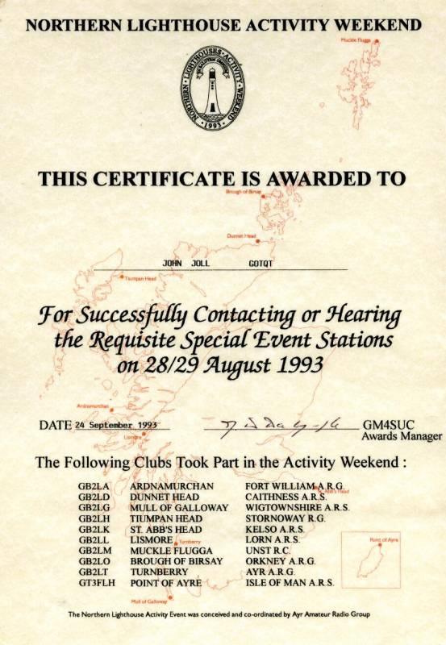

The following years the Scottish clubs were involved in a weekend activity with the theme of Scottish Firths (river estuaries), so two years elapsed before the next Northern Lighthouse Activity Weekend. During this period Anne-Grete OZ3AE enquired through a letter
to Practical Wireless if there was any
lighthouse activity on amateur radio.

Following discussions with her it was decided that Danish stations could join in the fun of the weekend. Quickly Germany, South Africa and France asked to join, so the name of weekend was changed to The International Lighthouse/Lightship Weekend . It was at this time that John, GM4OOU, due to pressure of work, had to cease his connections with the event.

The weekend became an annual event taking place over the third full weekend in August and has slowly grown in popularity. In 1999 there were 204 lighthouse/lightship stations in 36 countries and in 2011 469 stations in 55 countries took part.

The main reason the event has become so popular is because it is NOT a contest. It is a relaxed fun weekend without the pressure of a contest. The guidelines are simple and rely on the honesty of the operators to act within the spirit of the weekend which is simply to expose amateur radio and the plight of lighthouses to the public. This is why it is important for the ham station to be as close to the lighthouse/lightship as
possible with the controlling body’s approval.

